2013-10-19
MekHQ 0.3.4-dev-r1667
MekHQ^3 0.1.0-dev-r11

This document is intended to provide the newcomer to MekHQ with enough information to start using MekHQ in their campaign.

Let’s assume for the sake of this tutorial that you plan to use MekHQ to run a mercenary campaign; for anything else, you'll simply not use some of the programs features. I also assume you're already familiar both with MegaMek and the BattleTech rules.

1 Creating a Campaign
1.1 Setting your Initial Campaign Options
1.1.1 Name your Campaign
1.1.2
1.1.3
2 GUI Overview
2.1 Tabs
2.2 Menus
2.3 Daily Log

3 TO&E
3.1 Right Click Menu
3.2 TO&E Pilots & Units
4 Briefing Room
4.1 Buttons
4.2 Right Click Menu
5 Interstellar Map
5.1 Buttons
5.2 Mouse
5.3 Info Pane
6 Personnel
6.1 Right Click Menu
6.2 Views
7 Hangar
7.1 Right Click Menu
7.2 Views
8 Warehouse
8.1 Right Click Menu
8.2
9 Repair Bay
10 Infirmary
11 Mek Lab
12 Finances
13 Overview (MekHQ^3 Only)

1 Creating a Campaign
When you start MekHQ you will end up with the initial screen.
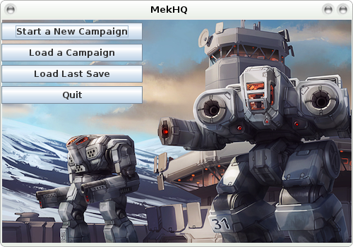
On this screen click the “Start New Campaign” button

1.1 Setting your Initial Campaign Options
Once you’ve clicked the button a splash screen will appear for a few seconds, and then the initial campaign options screen comes up.
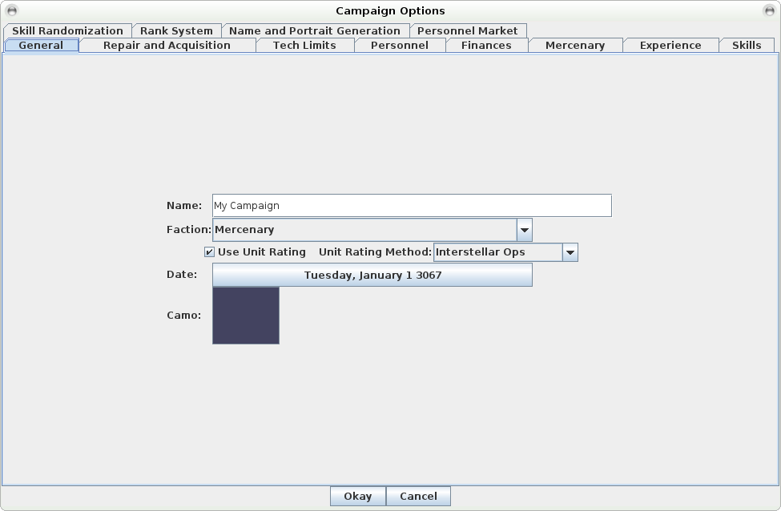
1.1.1 General Tab
On this screen you will be setting all of your initial campaign options. The most important are under the general tab: Campaign Name, Faction, Starting Date, and Unit Rating. Set the Name textbox to the name you wish to use for your campaign. I’ll use “Aces & Eights” for this example. For faction change the dropdown to the faction you wish to use. I’m going to leave it Mercenary since this is one of my merc units. I also leave the Use Unit Rating checkbox checked since I want to use ratings; however I’m changing the method dropdown from Interstellar Ops to FM: Mercenaries (rev). I set my date to November 25th 3058.
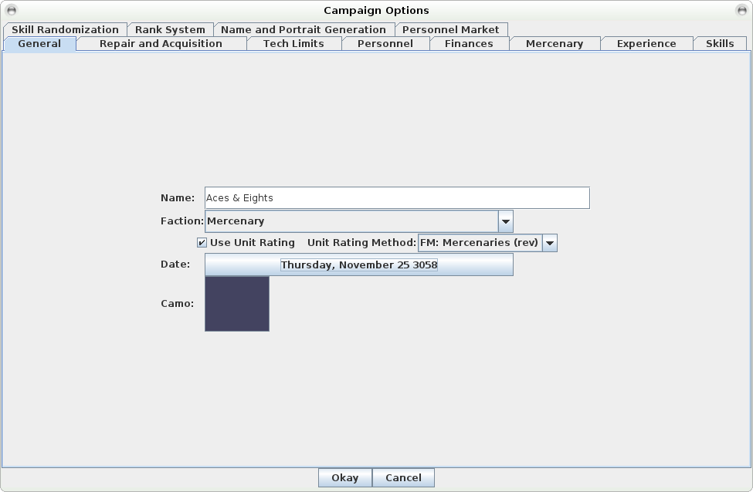
1.1.2 Repair and Acquisition
This tab has a lot of options. I’m not going to explain their function because they’re either in the rules or self-explanatory. For my purposes I’m turning off maintenance checks and setting my Acquisition Skill to “Scrounge”. I’ll also take this chance to set the number of acquisitions per cycle to 10. Finally I’ll check the boxes for Use Era Mods and Use Quirks.
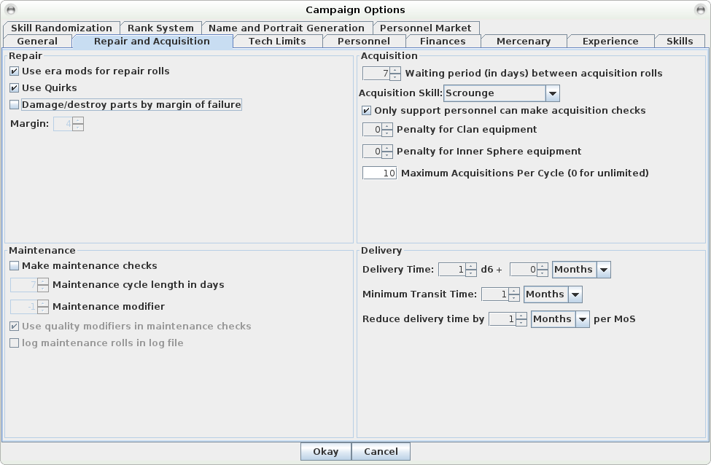
1.1.3 Tech Limits
There are only 6 options on this tab, and once again I’m not going to explain them all in detail since they should be obvious. For my purposes I’m going to leave the defaults with the exception of checking the unofficial option to use ammo by type. This option makes it so that ammo of the same type, but for different sized launchers (such as LRM 20 and LRM 5) can share ammo.
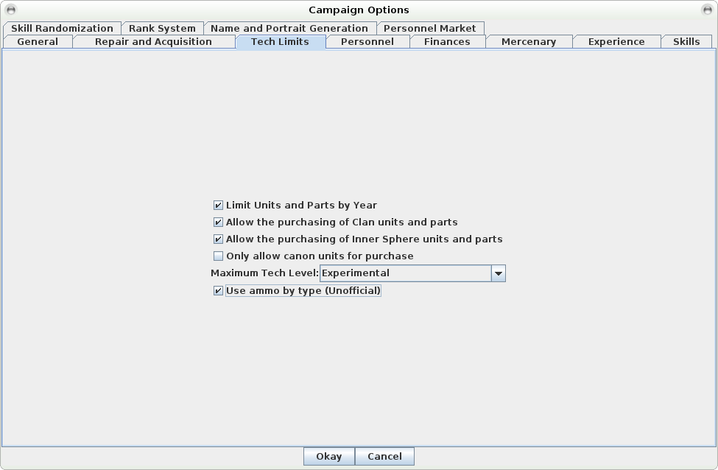
1.1.4 Personnel
The personnel tab contains almost all the possible rules, including some unofficial ones, for dealing with personnel. I’m going to set mine with the following checkboxes checked: Use Tactics, Use Toughness, Use Artillery, Allow Special Abilities, Use Pilot Edge, Allow Implants, Use Advanced Medical (Unofficial), Use Dylan’s Random XP (Unofficial), and Randomize the number of hits received by crews and infantry. The Advanced Medical Rules are documented in MekHQ/docs/advanced_medical_overview.txt.
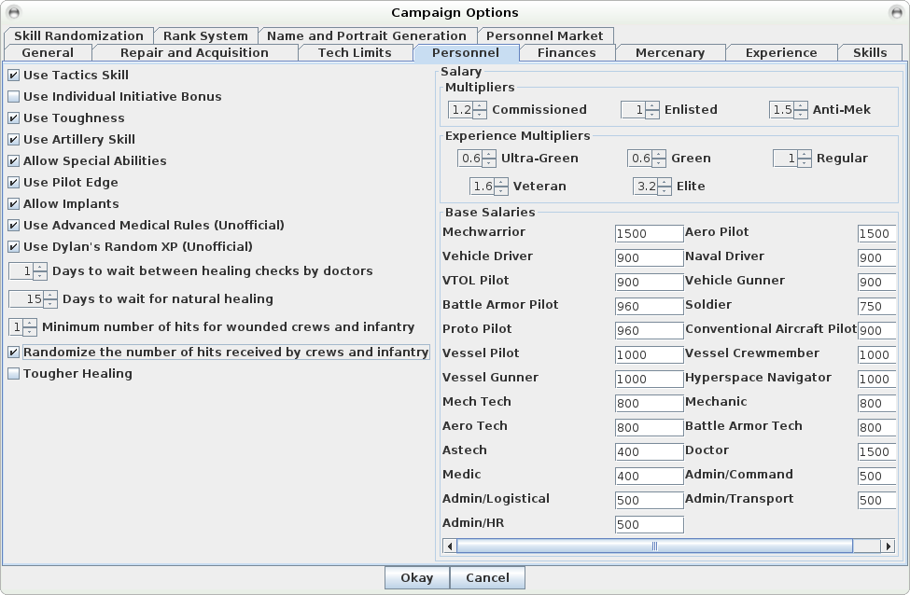
1.1.5 Finances
Since I’m playing a Mercenary unit, the finances tab is very important. I’ll need to pay for virtually everything. Because of that I’ll check everything except pay for recruitment. I’ll also set the Clan Price modifier to 2.2.
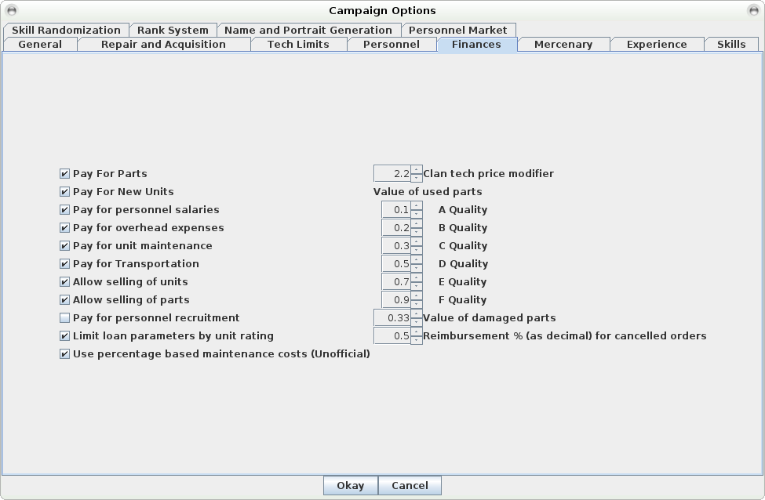
1.1.6 Mercenary
Another important tab when playing a Mercenary unit, though I suppose that much is obvious. I use the Interstellar Ops beta rules for my payment method at 0.5% and based on equipment sale value. I also use the checkbox to base Battle Loss Compensation on equipment sale value.
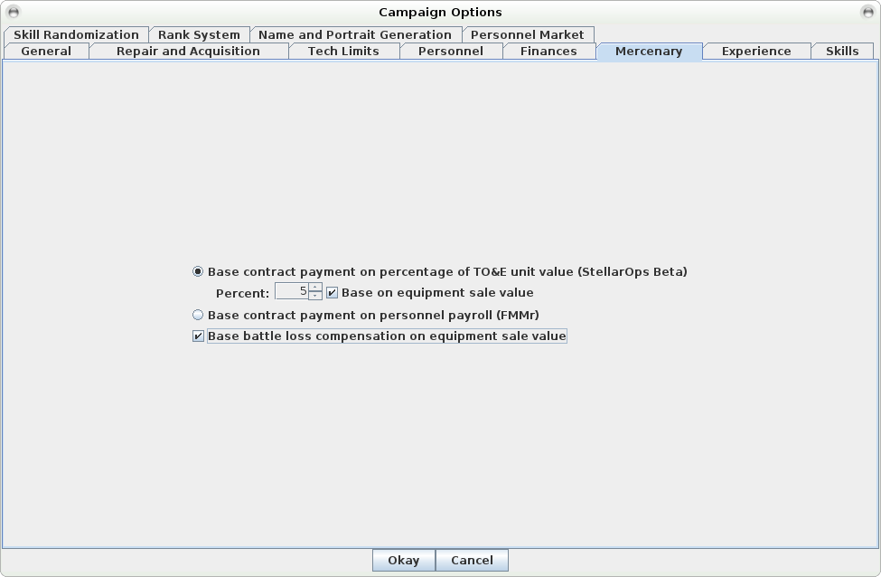
1.1.7 Experience
I’m not going to change anything on this tab because it takes too long. I copy and paste this particular data from campaign file to campaign file to get my settings. For those who wish to change them for either the first time or because they’re not comfortable copy/pasting in the campaign files, you can adjust the XP costs and rewards on this tab.
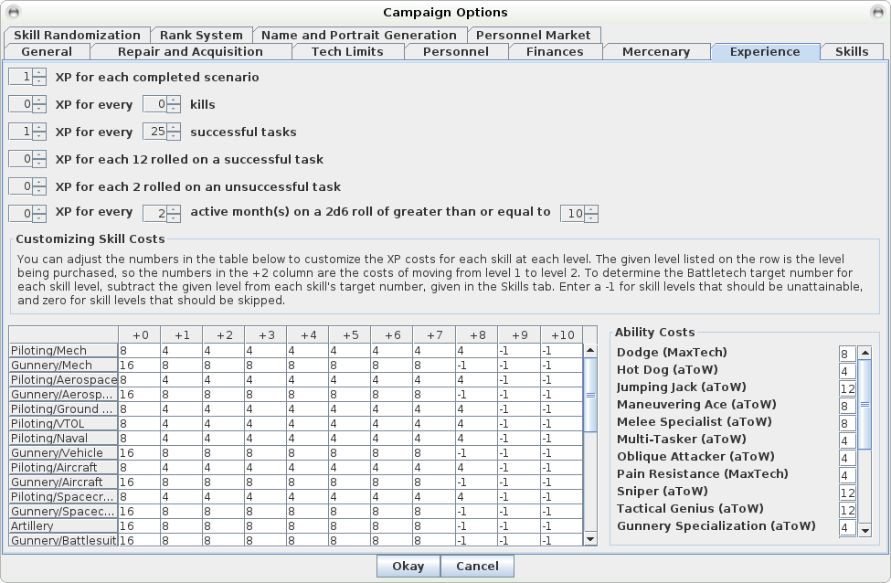
1.1.8 Skills
< Will Come Later>

1.1.9 Skill Randomization

2 GUI Overview
2.1 Tabs
2.2 Menus
2.3 Daily Log

3 TO&E
3.1 Right Click Menu
3.2 TO&E Pilots & Units
4 Briefing Room
4.1 Buttons
4.2 Right Click Menu
5 Interstellar Map
5.1 Buttons
5.2 Mouse
5.3 Info Pane
6 Personnel
6.1 Right Click Menu
6.2 Views
7 Hangar
7.1 Right Click Menu
7.2 Views
8 Warehouse
8.1 Right Click Menu
8.2
9 Repair Bay
10 Infirmary
11 Mek Lab
12 Finances
13 Overview (MekHQ^3 Only)

